Write method

f=open(*'F:\\python\\name.txt'*,*'w'*)

print(*'Enter the Name'*)

str = input()

f.write(str)

f.write(input())

f.close()

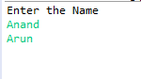

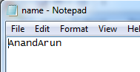

Append method

f=open(*'F:\\python\\name.txt'*,*'a'*)

print(*'Enter the Name'*)

str = input()

f.write(str)

f.write(input())

f.close()

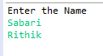

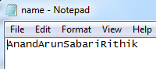

Read method

f=open(*'F:\\python\\name.txt'*,*'r'*)

print(f.read(12))

f.close()



Tell method

f=open(*'F:\\python\\name.txt'*,*'r'*)

print(f.tell())

print(f.read(7))

print(f.tell())

print(f.read(7))

print(f.tell())

print(f.read(7))

f.close()

